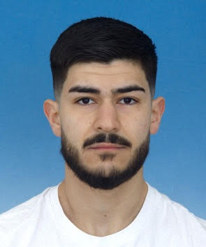

Снимка
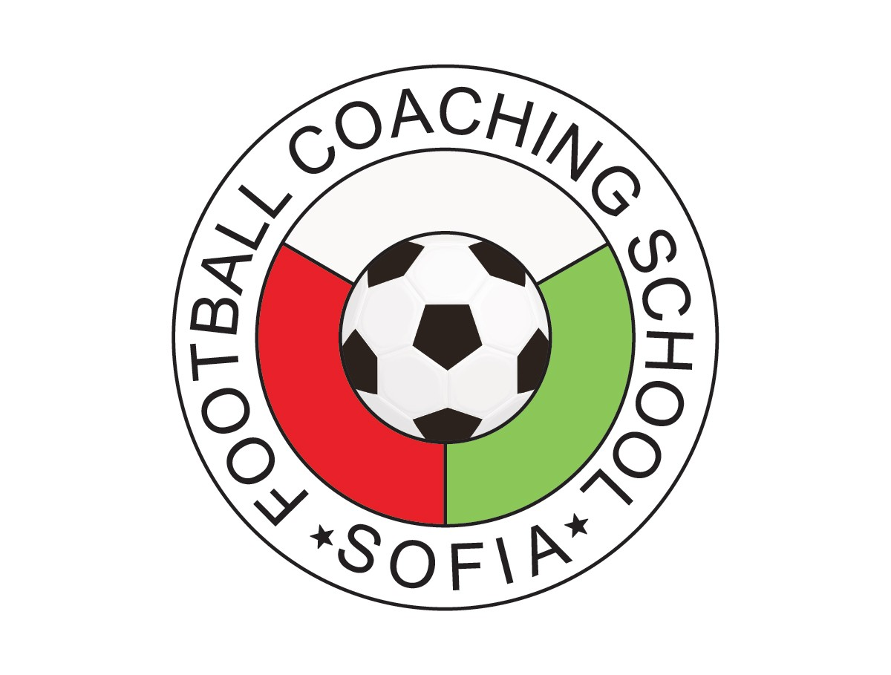
Curriculum Vitae

About

Name |  | Dzhamal Hakam Dzhamal Badzhes Al Badarin
Address |  | Nadezhda Street №3, Kazanlak, Bulgaria
Phone |  | +359 88888 1476
E-mail |  | jamalalbadarin@gmail.com
Nationality |  | Palestine / Bulgaria

Date of Birth |  | 06.06.2003

Professional Experience

Period (from –to) |  | January 2024 – until now
Name and Address of Football Club |  | FC „Rozova Dolina“ – Kazanlak, Bulgaria
Position |  | football player & 1st Team Assistant Coach

Period (from –to) |  | September 2023 – December 2023
Name and Address of Football Club |  | FC Shabab Al-Samu – Al-Samu, Palestine
Position |  | professional footballer

Period (from –to) |  | April 2023 – August 2023
Name and Address of Football Club |  | OFC "Academic" – Svishtov, Bulgaria
Position |  | - football player & 1st Team Assistant Coach;  - Head Coach – U19 & U17;  - General Coordinator - U19-U15

Period (from –to) |  | December 2022 – April 2023
Name and Address of Football Club |  | SG Eintracht Mendig-Bell – Mendich, Germany
Position |  | semi-professional footballer – senior team
Period (from –to) |  | January 2022 – November 2022
Name and Address of Football Club |  | FC "Rozova Dolina" – Kazanlak, Bulgaria
Position |  | football player & 1st Team Analysist
Period (from –to) |  | August 2021 – December 2021
Name and Address of Football Club |  | FC "Pirin II" – Blagoevgrad, Bulgaria
Position |  | football player – senior team
Period (from –to) |  | February 2021 – August 2021
Name and Address of Football Club |  | FC "Rozova Dolina" – Kazanlak, Bulgaria
Position |  | football player – senior team
Period (from –to) |  | January 2021 – February 2021
Name and Address of Football Club |  | POFC "Botev II" – Vratsa, Bulgaria
Position |  | football player – senior team
Period (from –to) |  | June 2020 – January 2021
Name and Address of Football Club |  | FC "Pirin" – Blagoevgrad, Bulgaria
Position |  | football player – U19 (Elite Group)
Period (from –to) |  | May 2019 – June 2020
Name and Address of Football Club |  | FC "Spartak 1919" – Pleven, Bulgaria
Position |  | football player – U17
Period (from –to) |  | July 2017 – May 2019
Name and Address of Football Club |  | PFC Beroe – Stara Zagora, Bulgaria
Position |  | football player – U15 / U16
Period (from –to) |  | June 2016 – July 2017
Name and Address of Football Club |  | PFC Ludogorets – Razgrad, Bulgaria
Position |  | football player – U14

Education

Period (from –to) |  | January 2023 – October 2024
Name of educational institution |  | Software University
Specialty |  | software engineering
Qualifying degree |  | Java Script Web Developer
Period (from –to) |  | Graduation - May 2022
Name of educational institution |  | GPCHE "Acad. Lyudmil Stoyanov" – Blagoevgrad
Specialty |  | English + German + IT
Qualifying degree |  | (B2+) (B1 / B2)

Personal qualities and Skills

Mother tongue |  | Bulgarian

Foreign languages

Language |  | Level
English language |  | B2+ / C1
German language |  | B1 / B2
Arabic language |  | A2

IT Skills |  | - Java Script Web Developer: JavaScript, Node JS, Angular, HTML, CSS  - Advanced Skills with Microsoft Office: Word, PowerPoint, Excel, Access
Additional information: |  | - experience with conducting 1-on-1 individual workouts  - guidelines and advice in structuring nutrition and training regimes  - interest in the study of sports psychology

